

**THE IMAGINATION UNIVERSITY PROGRAMME**

**RVfpga**

**Getting Started Guide**

# Acknowledgements



Table of Contents

Acknowledgements 2

1. INTRODUCTION 4

2. RISC-V INSTRUCTION SET ARCHITECTURE OVERVIEW 5

3. DESCRIPTION OF RVFPGA HARDWARE AND VERILOG 7



# INTRODUCTION

RISC-V FPGA, also written RVfpga, is a package that includes instructions, tools, and labs for targeting a commercial RISC-V processor to a field programmable gate array (FPGA). The term RVfpga also refers to the RISC-V system-on-chip (SoC) that you will use throughout this guide and the accompanying labs.

This RVfpga Guide first gives a brief introduction to the RISC-V computer architecture and describes SweRVolf, the RISC-V SoC that you will use throughout this guide and in the RVfpga Labs. The SweRVolf SoC is available as part of Imagination’s RVfpga download package (as well as from github) and is built around Western Digital’s (WD’s) SweRV EH1 core. We next describe the RVfpga Verilog file structure and show how to (1) install the tools needed to use RVfpga, (2) use Xilinx’s Vivado to download the SoC onto the Nexys A7 FPGA board, (3) use PlatformIO to run programs on RVfpga, (4) simulate RVfpga using Verilator, an HDL simulator, and (5) simulate RISC-V programs using Whisper, Western Digital’s RISC-V Instruction Set Simulator (ISS). Using Vivado and PlatformIO to download RVfpga to the Nexys A7 FPGA and run programs on it is the recommended method. However, as an alternative method, the appendices show how to install the native RISC-V toolchain (gnu compilers, debuggers, etc.) and use it with OpenOCD to download, run, and debug programs on RVfpga running on the Nexys A7 FPGA board.

Table 1 lists the software and hardware needed for RVfpga. This guide shows how to install and use these tools and hardware on the Ubuntu 18.04 operating system (OS).

Table 1. Required Software and Hardware for RVfpga

|  |  |  |
| --- | --- | --- |
| **Software** | | |
| **Name** | **Website** | **Cost** |
| Vivado 2019.2 WebPACK | <https://www.xilinx.com/support/download/index.html/content/xilinx/en/downloadNav/vivado-design-tools/2019-2.html> | free |
| VSCode | <https://code.visualstudio.com/Download> | free |
| PlatformIO | Installed within VSCode | free |
| Verilator (an HDL simulator) | Installed within PlatformIO | free |
| Whisper (Western Digital’s RISC-V Instruction Set Simulator) | Installed within PlatformIO | free |
| RISC-V Toolchain and OpenOCD | Installed within PlatformIO | free |
| **Hardware** | | |
| **Name** | **Website** | **Cost** |
| Nexys A7 FPGA Board* | <https://store.digilentinc.com/nexys-a7-fpga-trainer-board-recommended-for-ece-curriculum/> | $265  (academic price: $199) |
| RISC-V Core and System-on-Chip (SoC)** | | |
| **Name** | **Website** | **Cost** |
| Western Digital’s  SweRV EH1 Core | <https://github.com/chipsalliance/Cores-SweRV> | free |
| SweRVolf | <https://github.com/chipsalliance/Cores-SweRVolf> | free |

* All of the steps described in this guide also work on Digilent’s Nexys4 DDR FPGA board.

** Provided with the RVfpga download from Imagination Technologies

**IMPORTANT:** Before beginning, copy the **RVfpga** folder that you downloaded from Imagination’s University Programme to your Ubuntu machine. We will refer to the absolute path of the directory where you place folder RVfpga as [RVfpgaPath]. You will find three folders inside RVfpga: (1) **examples**, which contains several example programs that you will run along this guide, (2) **src**, which contains the sources for the baseline SoC that we will use in this course, and (3) **verilatorSIM**, which contains the scripts for running the simulation in Verilator.

# RISC-V INSTRUCTION SET ARCHITECTURE OVERVIEW

RISC-V is an Instruction Set Architecture (ISA) that was created in 2011 in Par Lab at the University of California, Berkeley. The goal was for RISC-V to become a “Universal ISA” for processors used for the entire range of applications, from small, constrained, low-resource IoT devices to supercomputers. RISC-V architects established five principles for the architecture to achieve this goal:

* It must be compatible with a wide range of software packages and programming languages.
* Its implementation must be feasible in all technology options, from FPGAs to ASICs (application specific integrated circuits) as well as emerging technologies.
* It must be efficient in the various microarchitecture scenarios, including those implementing microcode or hardwired control, in-order or out-of-order pipelines, various types of parallelism, etc.
* It must be able to be tailored to specific tasks to achieve the required maximum performance without drawbacks imposed by the ISA itself.
* Its base instruction set must be stable and long-lasting, offering a common and solid framework for developers.

RISC-V is an open standard, in fact, the specification is public domain, and it has been managed since 2015 by the **RISC-V Foundation**, now called **RISC-V International**, a non-profit organization promoting the development of hardware and software for RISC-V architectures. In 2018, the RISC-V Foundation began an ongoing collaboration with the Linux Foundation, and in March 2020 the RISC-V Foundation became RISC-V International headquartered in Switzerland. This transition dissipated any concern the community might have had about future openness of the standard. As of 2020, RISC-V International is supported by more than 200 key players from research, academia, and industry, including Microchip, NXP, Samsung, Qualcomm, Micron, Google, Alibaba, Hitachi, Nvidia, Huawei, Western Digital, ETH Zurich, KU Leuven, UNLV, and UCM.

RISC-V is one of the few, and probably the only, globally relevant ISAs created in the past 10-20 years because of it being an open standard and modular, instead of incremental. Its modularity makes it both flexible and sleek Processors implement the base ISA and only those extensions that are used. This modular approach differs from traditional ISAs, such as x86 or ARM, that have incremental architectures, where previous ISAs are expanded and each new processor must implement all instructions, even those that are tagged as “obsolete”, to ensure compatibility with older software programs. As an example, x86, that started with 80 instructions, has now over 1300, or 3600 if you consider all different opcodes available in machine code. This large number of instructions and the requirement of backward compatibility result in large, power-hungry processors that must support long instructions, because most of the short opcodes, or small instructions, are already in use.

RISC-V has four base ISA options: two 32-bit versions (integer and embedded versions, RV32I and RV32E) and 64- and 128-bit versions (RV64I and RV128I), as shown in Table 2. The ISA modules marked Ratified have been ratified at this time. The modules marked Frozen are not expected to change significantly before being put up for ratification. The modules marked Draft are expected to change before ratification. The ability to build small processors is a particularly key requirement for cost-, space-, and energy-constrained devices. Instruction extensions can be added on top of these base ISAs to enable specific tasks, for example floating point operations, multiplication and division, and vector operations. These specialized hardware extensions are also included in the standard and known by the compilers, so enabling the desired options in a compiler will allow for a targeted binary code generation. Each of these extensions is identified by a letter that must be added to the core ISA to represent the hardware capabilities of the implementation, as shown in Table 3. For example, RVM is the multiply/divide extension, RVF is the floating-point extension, and so on.

**Table 2. RISC-V base ISAs (table from https://riscv.org/specifications/isa-spec-pdf/)**

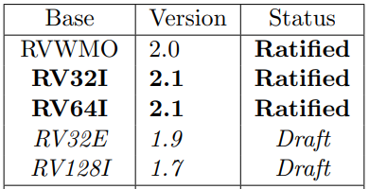

Table 3. RISC-V standard ISA extensions (table from https://riscv.org/specifications/isa-spec-pdf/)

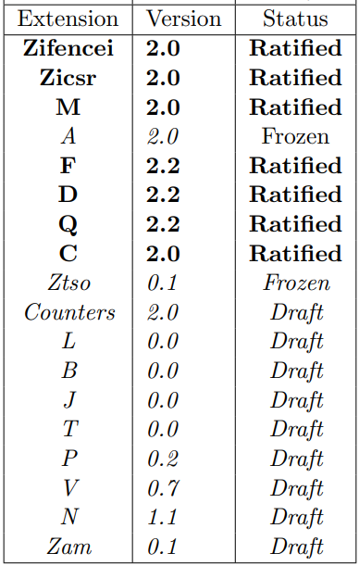

The letter G, that denotes “general”, is used to denote the inclusion of all MAFD extensions. Note that a company or an individual may develop proprietary extensions using opcodes that are guaranteed to be unused in the standard modules. This allows third-party implementations to be developed in a faster time-to-market.

For example, a 64-bit RISC-V implementation, including all four general ISA extensions plus *Bit Manipulation* and *User Level Interrupts*, is referred to as an RV64GBN ISA. All these modules are covered in the unprivileged or user specification. The RISC-V foundation also covers a set of requirements and instructions for privileged operations required for running general-purpose operating systems.

# DESCRIPTION OF RVFPGA HARDWARE AND VERILOG

In this section we describe the entire RVfpga system from the core up to the FPGA board interface. Figure 1 illustrates the typical hierarchical organization of an embedded system starting with the processor core, then the SoC built around the core, and finally the system and board interface. We start by describing the processor core (**Western Digital’s SweRV EH1 Core**), which executes the RISC-V instructions; then, in Section B, we describe the **SweRVolf SoC**, which integrates the system’s hardware components (core, memory, and input/output); in Section C we describe the SweRVolf SoC implemented on the Nexys A7 FPGA board (**RVfpga**) and also describe the SweRVolf SoC used in simulation (**RVfpgaSIM**). Finally, we explain the file structure of the whole RVfpga system in Section D.

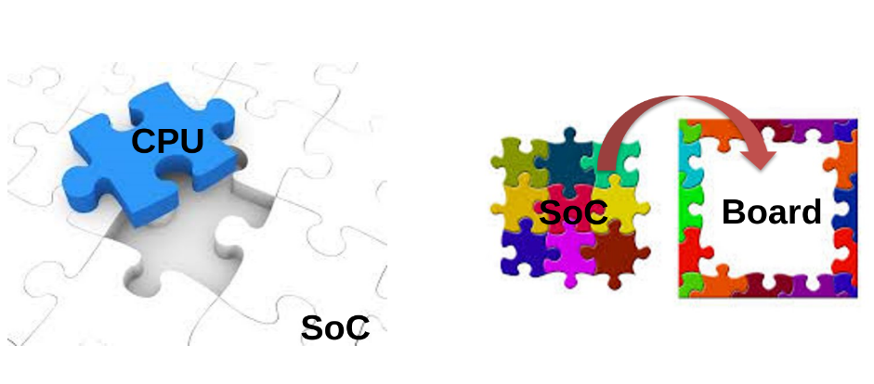

Figure 1. Embedded System organization

* 1. **SweRV EH1 Core and SweRV EH1 Core Complex**

Western Digital developed three RISC-V cores over the past few years: **SweRV EH1** (the core used in RVfpga), SweRV EH2, and SweRV EL2. Each core has an Apache 2.0 license. The SweRV Core EH1 is a 32-bit, 2-way superscalar, 9-stage pipeline core. The SweRV Core EH2 builds on and expands the EH1 core to add dual threaded capability for additional performance. The SweRV Core EL2 is a smaller core with moderate performance. The RISC-V page at <https://www.westerndigital.com/company/innovations/risc-v> outlines the three available cores, whose main features are given in Table 4.

**Table 4. Main features of the three WD RISC-V Cores**

(table from <https://www.westerndigital.com/company/innovations/risc-v>)

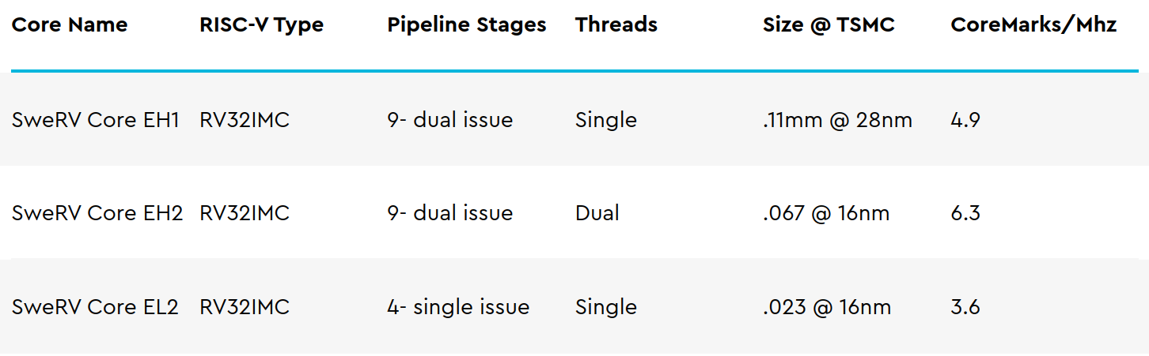

Out of the three cores, the **SweRV EH1 Core** (provided with the RVfpga package and also available from <https://github.com/chipsalliance/Cores-SweRV>) is preferred for its high performance/MHz and its simple thread structure. Moreover, Chips Alliance, a group committed to providing open-source hardware, provides a complete and verified SoC, called SweRVolf (provided with the RVfpga package and also available from <https://github.com/chipsalliance/Cores-SweRVolf>). RVfpga uses the SweRVolf SoC that, in turn, uses Western Digital’s **SweRV Core EH1** version **1.6**.

The **SweRV EH1 Core** is a machine-mode (M-mode) only, 32-bit CPU core which supports RISC-V’s integer (I), compressed instruction (C), and integer multiplication and division (M) extensions. The Programmer’s Reference Manual (<https://github.com/chipsalliance/Cores-SweRV/blob/master/docs/RISC-V_SweRV_EH1_PRM.pdf>) describes in detail all aspects of the core, from its structure to timing information and memory maps. SweRV EH1 is a superscalar core, with a dual-issue 9-stage pipeline (see Figure 2) that supports four arithmetic logic units (ALUs), labelled EX1 to EX4 in two pipelines, I0 and I1. Both ways of the pipeline support ALU operations. One way of the pipeline supports loads/stores and the other way has a 3-cycle latency multiplier. The processor also has one out-of-pipeline 34-cycle latency divider. Four stall points exist in the pipeline: ‘Fetch 1’, ‘Align’, ‘Decode’, and ‘Commit’. The ‘Fetch 1’ stage includes a Gshare branch predictor. In the ‘Align’ stage, instructions are retrieved from three fetch buffers. In the ‘Decode’ stage, up to two instructions from four instruction buffers are decoded. In the ‘Commit’ stage, up to two instructions per cycle are committed. Finally, in the ‘Writeback’ stage, the architectural registers are updated.

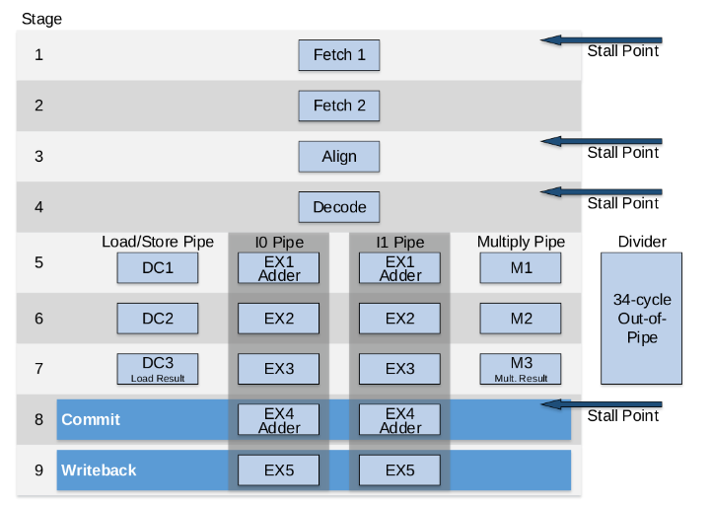

Figure 2. SweRV EH1 core microarchitecture

(figure from <https://github.com/chipsalliance/Cores-SweRV/blob/master/docs/RISC-V_SweRV_EH1_PRM.pdf>)

Figure 3 shows a comparison of different current cores and processors. The SweRV EH1 Core performance per MHz is impressively high at 4.9 CM/MHz (CoreMark per MHz): it is twice as fast as the ARM Cortex A8 and its performance even surpasses the ARM Cortex A15 performance.

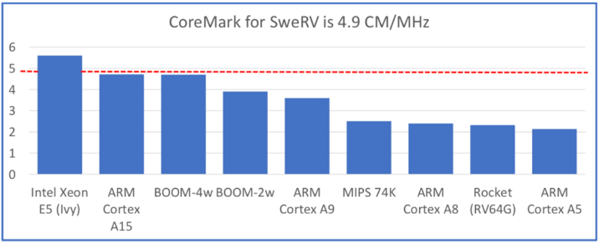

Figure 3. Benchmark comparison per thread and MHz

(figure from <https://content.riscv.org/wp-content/uploads/2019/12/12.11-14.20a3-Bandic-WD_SweRV_Cores_Roadmap_v4SCR.pdf>)

Western Digital also provides an extension to the SweRV EH1 Core called the **SweRV EH1 Core Complex** (see Figure 4), which adds the following elements to the EH1 Core:

* Two dedicated memories, one for instructions (ICCM) and the other for data (DCCM), which are tightly coupled to the core. These memories provide low-latency access and SECDED ECC (single-error correction and double-error detection error correcting codes) protection. Each of the memories can be configured as 4, 8, 16, 32, 48, 64, 128, 256, or 512KB.
* An optional 4-way set-associative instruction cache with parity or ECC protection.
* An optional Programmable Interrupt Controller (PIC), that supports up to 255 external interrupts.
* Four system bus interfaces for instruction fetch (IFU Bus Master), data accesses (LSU Bus Master), debug accesses (Debug Bus Master), and external DMA accesses (DMA Slave Port) to closely coupled memories (configurable as 64-bit AXI4 or AHB-Lite buses).
* Core Debug Unit compliant with the RISC-V Debug specification.

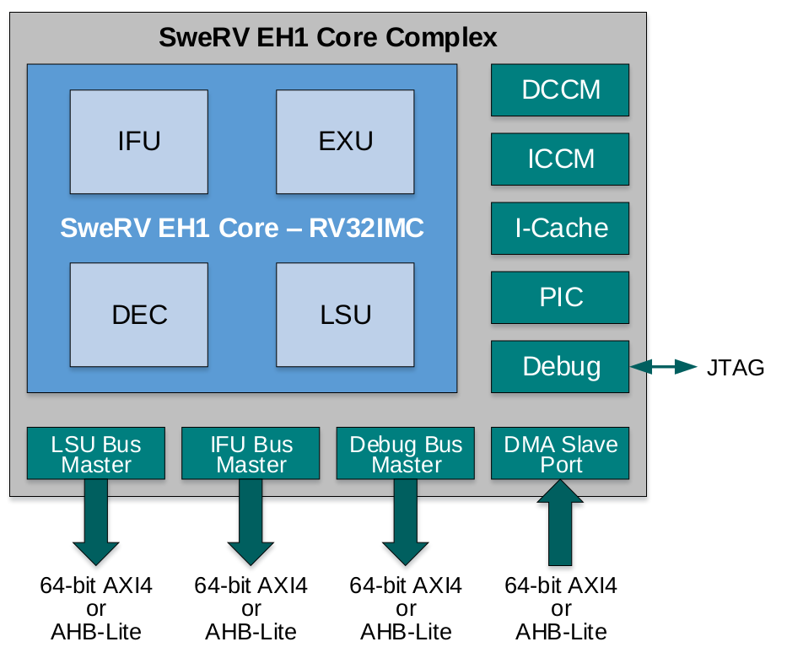

Figure 4. SweRV EH1 Core Complex

(figure from <https://github.com/chipsalliance/Cores-SweRV/blob/master/docs/RISC-V_SweRV_EH1_PRM.pdf>)

* 1. **SweRVolf SoC**

In this RVfpga package, we use the **SweRVolf SoC version 0.7**, which is built on top of the SweRV EH1 Core Complex. The SweRVolf SoC is provided with the RVfpga download (Figure 5) and is also available at: <https://github.com/chipsalliance/Cores-SweRVolf/releases/tag/v0.7>.

In addition to the SweRV EH1 Core Complex (see Figure 4), the SweRVolf SoC also includes a Boot ROM, a uART, a System Controller and an SPI controller (Figure 5 shows these elements in white). In this course we extend the SweRVolf SoC with some more functionality, such as another SPI controller (SPI2), a GPIO (General Purpose Input/Output) and a timer (Figure 5 shows these peripherals in red). Given that the SweRV EH1 Core uses an AXI bus and the peripherals use a Wishbone bus, the SoC also has an AXI-Wishbone Bridge.



Figure 5. SweRVolf SoC

Table 5 shows the memory-mapped addresses of the peripherals connected to the core via the Wishbone interconnect.

Table 5. Memory-mapped addresses of SweRVolf SoC peripherals

|  |  |
| --- | --- |
| **System** | **Address** |
| Boot ROM | 0x80000000 - 0x80000FFF |
| System Controller | 0x80001000 - 0x8000103F |
| SPI1 | 0x80001040 - 0x8000107F |
| SPI2 | 0x80001100 - 0x8000113F |
| Timer | 0x80001200 - 0x8000123F |
| GPIO | 0x80001400 - 0x8000143F |
| UART | 0x80002000 - 0x80002FFF |

1. **Input/Output**

The SweRVolf SoC uses two kinds of hardware controllers for communicating with the peripherals: custom controllers written in Verilog and open-source controllers from OpenCores [<https://opencores.org/>], an online community for the development of gateware IP (Intellectual Properties) cores in the spirit of free and open source collaboration. The SweRVolf SoC that we use in this course includes the I/O interfaces listed below, which we will use, explain in detail and even extend in RVfpga Labs 6-10.

* **System Controller:** the system controller contains common system functionality such as keeping register with the SoC version information, RAM initialization status and the RISC-V machine timer (at <https://github.com/chipsalliance/Cores-SweRVolf> you can find the complete memory map). Moreover, we have extended the System Controller with two registers for storing the value to show in the 8-digit 7-Segment Displays available on the Nexys A7 board, mapped in addresses 0x80001038 and 0x8000103C.
* **SPI:** two open-source SPI controllers (obtained from <https://opencores.org/projects/simple_spi>) are implemented in SweRVolf. Their exposed registers (SPI_SPCR, SPI_SPSR, SPI_SPDR, SPI_SPER, SPI_SPSS) are mapped between addresses 0x80001040 and 0x8000107F and between addresses 0x80001100 and 0x8000113F.
* **Timer:** We use the timer module from [https://opencores.org/projects/ptc](https://opencores.org/projects/ptcb). Its registers are mapped in the address range 0x80001200 to 0x800012FF.
* **GPIO:** We use the GPIO controller from <https://opencores.org/projects/gpio>. It includes 32 I/O ports mapped in the address range 0x80001400 to 0x800014FF. Each pin is connected with a tristate buffer module, so that it can be configured as an input or an output.
* **UART:** an open-source UART controller (obtained from <https://opencores.org/projects/uart16550>) is available in SweRVolf. Its exposed registers are mapped between addresses 0x80002000 and 0x80002FFF.

1. **Memory**

The SweRVolf SoC includes a Boot ROM memory and the necessary hardware to enable the user to include RAM and SPI Flash memories.

* **Boot ROM:** a Boot ROM contains a first-stage bootloader. After system reset, the SweRVolf SoC will start fetching the initial instructions from this area, which occupies addresses 0x80000000 to 0x80000FFF.
* **RAM:** the SweRVolf SoC does not include a memory controller, but it reserves the first 128MiB of its memory map (0x00000000-0x07FFFFFF) and exposes the AXI bus, so that the user can access RAM memory by using a memory controller.
* **SPI Flash:** an SPI Flash memory can also be included using the SPI controller described in the previous section (address range: 0x80001040-0x8000107F).

1. **Interconnection**

The SweRV EH1 core uses an AXI4 bus to connect the core and memory. The bus could also be configured as an AHB-Lite bus, but we will not use that option in these materials. All of the peripherals (I/O devices) are connected to a Wishbone bus, an open source bus that is heavily used in OpenCore CPU’s and peripherals. The system includes an AXI to Wishbone Bridge (as shown in Figure 5) to connect the core to the peripherals.

In this section, we briefly describe the operation of an AXI4 bus and a Wishbone bus. If you are interested in extending your knowledge about the specification of these buses, you can use the references provided below.

**The AXI4 Bus**

The SweRV EH1 Core Complex uses an AXI4 Interconnect for communicating with the outside world (see Figure 4). The Advanced eXtensible Interface (AXI) is a common bus used by many processors and it is part of the ARM Advanced Microcontroller Bus Architecture on-chip interconnect specification.

In the following subsections, we briefly explain some of the main aspects of the AXI4 interconnect. You can find the whole AXI specification in the following document: <https://static.docs.arm.com/ihi0022/e/IHI0022E_amba_axi_and_ace_protocol_spec.pdf>

* **AXI Bus Main Features**

The main features of the AXI bus technology are as follows:

* + It is suitable for both high-bandwidth and low-latency designs
  + It provides high-frequency operation without using complex bridges
  + It can meet the interface requirements of a wide range of components
  + It is suitable for memory controllers with high initial access latency
  + It provides flexibility in the implementation of interconnect architectures
  + It is backward compatible with existing AHB and APB interfaces
  + It provides separate address/control and data phases
  + It includes support for unaligned data transfers (using byte strobes)
  + It allows burst-based transactions with only the start address issued
  + It provides separate read and write data channels, which can allow low-cost DMA
  + It allows address information to be issued ahead of the actual data transfer
  + It provides support for issuing multiple outstanding addresses and out-of-order transaction completion
  + It allows easy addition of register stages to provide timing closure
* **AXI Architecture**

The AXI protocol defines the following independent transaction channels:

* Read address
* Read data
* Write address
* Write data
* Write response

Figure 6 shows how a read transaction uses the read address and read data channels. First the address and control bits are sent from the master device, then the slave device responds with the data on the read data channel.

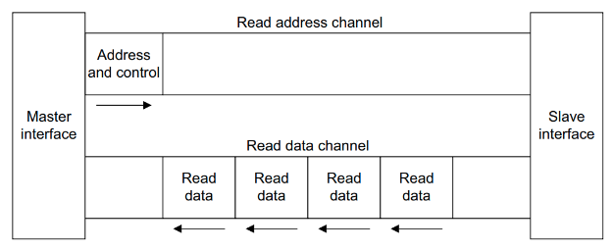

Figure 6. Channel architecture of reads

(figure from <https://static.docs.arm.com/ihi0022/e/IHI0022E_amba_axi_and_ace_protocol_spec.pdf>)

Figure 7 shows how a write transaction uses the write address, write data, and write response channels. Similar to a read, the master device sends the address and control bits. Then the master device sends the data on the write data channel and the slave device sends a response.

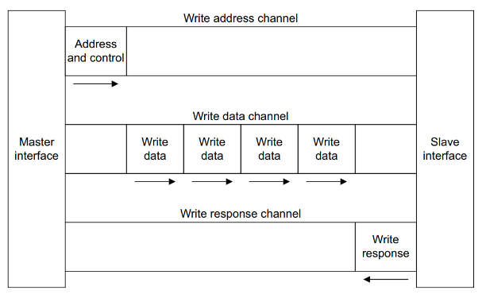

Figure 7. Channel architecture of writes

(figure from <https://static.docs.arm.com/ihi0022/e/IHI0022E_amba_axi_and_ace_protocol_spec.pdf>)

The AXI address channel carries addresses and control information that describes the nature of the data to be transferred. The data is transferred between the master and slave using either:

* A read data channel to transfer data from the slave to the master (Figure 6).
* A write data channel to transfer data from the master to the slave (Figure 7). In a write transaction, the slave uses the write response channel to signal the completion of the transfer to the master (Figure 7).
* **AXI Signals**

Table 6. shows the main signals used in the AXI bus and a brief description of each of them. The signals are organized in five groups, which correspond to the five channels described in the previous section:

* **Write address channel** signals, whose names start with **AW**
* **Write data channel** signals, whose names start with **W**
* **Write response channel** signals, whose names start with **B**
* **Read address channel** signals, whose names start with **AR**
* **Read data channel** signals, whose names start with **R**

Table 6. AXI Signals

(table from <https://static.docs.arm.com/ihi0022/e/IHI0022E_amba_axi_and_ace_protocol_spec.pdf>)

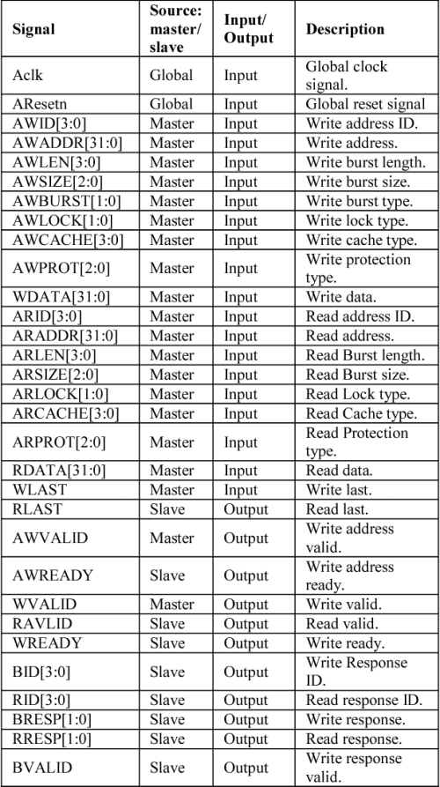

**The Wishbone bus**

The RVfpga (SweRVolf) peripherals use the Wishbone System-on-Chip (SoC) Interconnection Architecture for Portable IP Cores (<https://opencores.org/howto/wishbone>). The main purpose of this bus is to foster design reuse by alleviating System-on-Chip integration problems. Previously, IP cores used non-standard interconnection schemes that made them difficult to integrate. These non-standard interconnects required the creation of custom glue logic to connect each of the cores together. By adopting a standard interconnection scheme such as the Wishbone bus, cores can be integrated more quickly and easily by the end user.

* **Wishbone main features**

The main features of this Wishbone bus technology are as follows:

* + It supports structured design methodologies used by large project teams.
  + It includes a full set of popular data transfer bus protocols including:
    1. READ/WRITE cycles
    2. BLOCK transfer cycles
    3. READ/MODIFY/WRITE cycles
  + It provides modular data bus widths and operand sizes up to 64-bits.
  + It supports both BIG ENDIAN and LITTLE ENDIAN data ordering.
  + It supports various core interconnection methods including point-to-point, shared bus, crossbar switch, and switched fabric interconnections.
  + It includes handshaking protocols that allow each IP core to throttle its data transfer speed.
  + It supports single clock data transfers.
  + It supports normal cycle termination, retry termination, and termination due to error.
  + It includes modular address widths.
  + It provides a partial address decoding scheme for slaves. This facilitates high speed address decoding, uses less redundant logic, and supports variable address sizing and interconnection methods.
  + It provides user-defined tags. These are useful for applying information to an address or data bus or a bus cycle. User-defined tags are especially helpful when modifying a bus cycle to identify information such as:
    1. Data transfers
    2. Parity or error correction bits
    3. Interrupt vectors
    4. Cache control operations
  + It includes a Master/Slave architecture for flexible system designs.
  + It has multiprocessing (multi-MASTER) capabilities. This allows for a wide variety of SoC configurations
  + It includes an arbitration methodology that can be defined by the end user (priority arbiter, round-robin arbiter, etc.)
* **Wishbone Architecture and Signals**

Figure 8 illustrates the standard connection between a master (in our case, the SweRV EH1 Core) and a slave (in our case, a peripheral such as the GPIO, the SPI…) through a Wishbone bus. The Wishbone bus is much simpler than the AXI4 bus and, as shown in Table 7, it uses fewer signals.

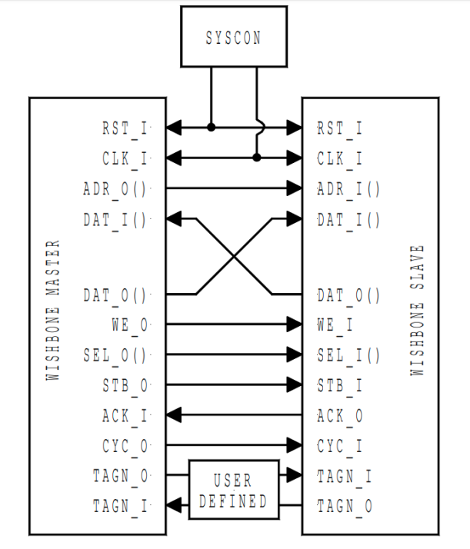

Figure 8. Wishbone Architecture

(figure from <https://opencores.org/howto/wishbone>)

Table 7. Wishbone Signals

(table from <https://opencores.org/howto/wishbone>)

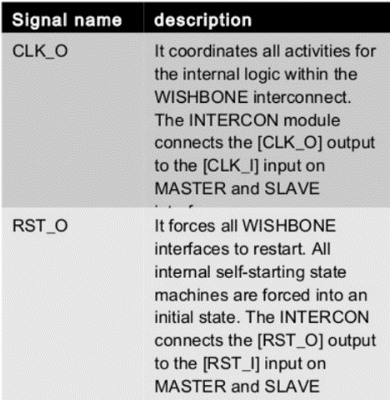 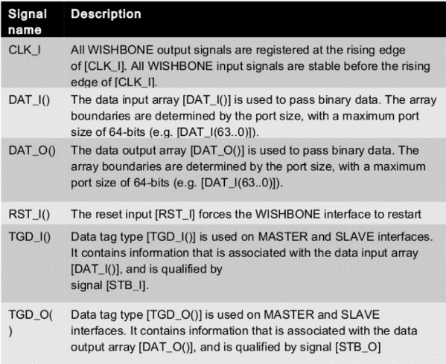

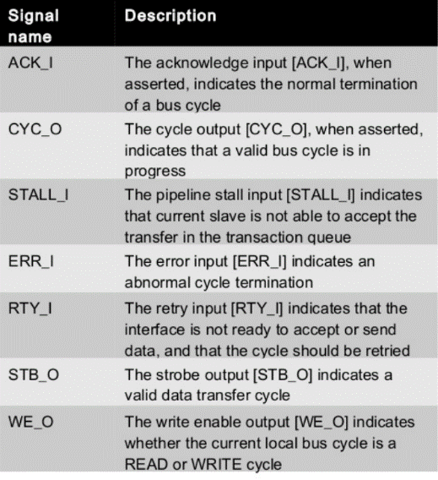 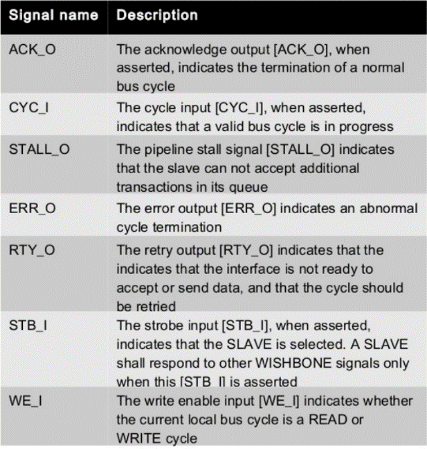

* 1. **SweRVolf SoC on the Nexys A7 FPGA Board and in Simulation**

The SweRVolf SoC (Figure 5) can run either (1) on the Nexys A7 (or Nexys DDR) FPGA board, which configuration is referred to as **RVfpga,** or (2) in simulation, which is referred to as **RVfpgaSIM**.

1. **RVfpga**

RVfpga is the SweRVolf SoC targeted to the Nexys A7 FPGA board and its peripherals. (Recall that the Nexys 4 DDR FPGA board can also be used). The main elements used by **RVfpga** are illustrated in Figure 9:

* Hardware programmed onto the FPGA:
  + **SweRVolf SoC**
  + **Lite DRAM controller**
* Peripherals used in RVfpga from the Nexys A7 (or Nexys4 DDR) FPGA board:
  + **DDR2 memory** (accessed through the Lite DRAM controller mentioned above)
  + **USB** connection
  + **SPI Flash memory**
  + **SPI Accelerometer**
  + **16 LEDs** and **16 Switches**
  + **8-digit 7-Segment Displays**



Figure 9. RVfpga

Digilent’s Nexys A7 FPGA board (Figure 10) costs $265 (or a discounted price of $198.75 with academic pricing – sign up for a Digilent account with a .edu email address). The Nexys A7 board is a recommended trainer board for electrical and computer engineering curricula. Digilent provides an extensive reference manual of this board at: <https://reference.digilentinc.com/_media/reference/programmable-logic/nexys-a7/nexys-a7_rm.pdf>. This board may be powered from a 5V wall wart (not provided with the board) or from a PC via the microUSB connector on the board. A Microchip PIC24 microcontroller manages the loading process onto the FPGA, making this board a user-friendly option. The board is programmable using Xilinx’s Vivado Design Suite. The desired configuration can be downloaded to the FPGA using one of four different sources: a FAT32 formatted MicroSD card, a FAT32 formatted USB pendrive, the internal flash memory, or a JTAG interface.

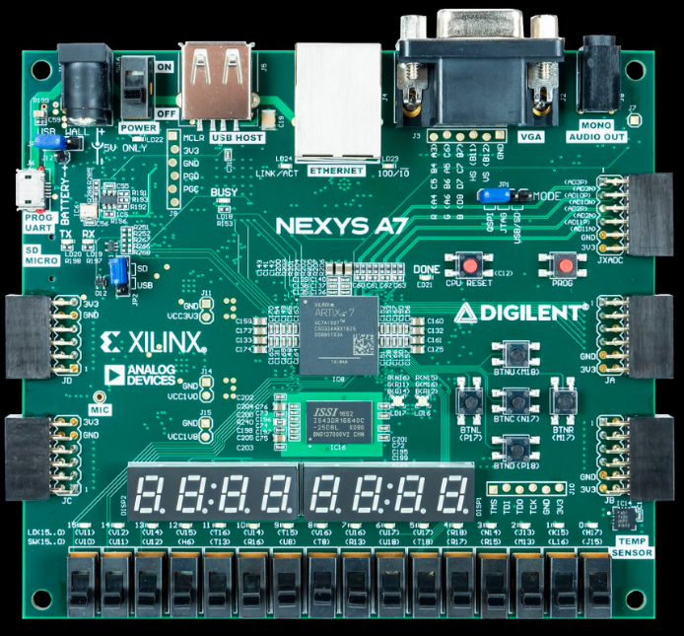

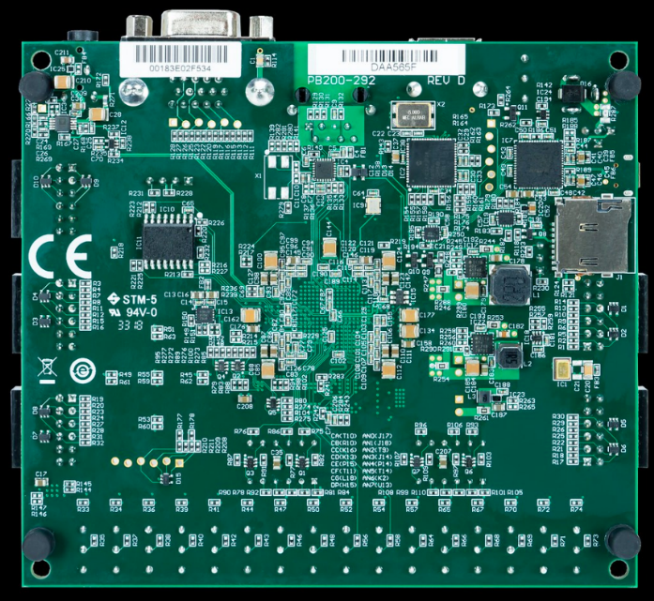

Figure 10. Digilent’s Nexys A7 FPGA board

(figure from https://reference.digilentinc.com/)

The Nexys A7-100T FPGA board includes the following interfaces and devices:

* 128 MiB DDR RAM
* 128 Mibit SPI Flash Memory
* 8-digit 7-Segment Displays
* 16 Switches
* 16 LEDs
* Sensors and connectors, including a microphone, audio jack, VGA 25 port, USB host port, RGB-LEDs, temperature sensor, accelerometer, among other.
* Xilinx Artix-7 FPGA, which has the following features:
  + 15.850 Logic slices of four 6-input LUTs and 8 flip-flops.
  + 4.860 Kibits of total block RAM
  + 6 clock management tiles (CMTs)
  + 170 I/O pins
  + 450 MHz internal clock frequency

1. **RVfpgaSIM**

The SweRVolf SoC can also include a Verilog wrapper to enable simulation. This is referred to as **RVfpgaSIM**, which is a simulation target that wraps the SweRVolf SoC in a testbench to be used by HDL simulators. It can be used in two ways:

* For full-system simulations in Verilator (or other HDL simulators)
* For connecting to a debugger through OpenOCD and JTAG VPI

Although many open-source HDL simulators exist, we use Verilator (<https://www.veripool.org/wiki/verilator>). This open and free HDL simulator accepts synthesizable Verilog or SystemVerilog and it claims to be the fastest Verilog/SystemVerilog simulator. It is widely used in industry and academia; it provides out-of-the-box support from ARM and RISC-V vendor IPs; and it is guided by Chips Alliance and the Linux Foundation.

* 1. **File Structure**

In the previous sections we have shown the high-level organization of the system that we use in these materials, from the **SweRV EH1 Core Complex** (Figure 4), to the **SweRVolf SoC** (Figure 5) and, finally, to **RVfpga** (Figure 9) and **RVfpgaSIM** implementations.

In this section, we describe the file structure of the whole system. While reading these explanations, open the files and view them on your PC. The files are available at ***[RVfpgaPath]/RVfpga/src***.

1. **SweRV EH1 Core Complex**

Figure 11 shows the file structure of the **SweRV EH1 Core Complex** (Figure 4). The core is organized into three main blocks: a SweRV wrapper that includes the SweRV EH1 Core (highlighted in green) and some other elements (such as the Interrupt Controller), the differential memory interface (DMI) and the Data/Instruction memories.



Figure 11. SweRV EH1 Core Complex

The Verilog files for the SweRV EH1 Core Complex are available in this folder:

***[RVfpgaPath]/RVfpga/src/SweRVolfSoC/SweRVEh1CoreComplex***

Find that directory on your PC to view the files as we refer to them in this section.

The top file for the SweRV EH1 Core Complex is in the file: *swerv_wrapper.sv*; the top module is called **swerv_wrapper**, and it instantiates two modules that correspond to the two blocks highlighted in Figure 11:

* **mem** (implemented inside *mem.sv*): this module instantiates the modules for the implementation of the DCCM (**lsu_dccm_mem**, implemented in file *lsu/lsu_dccm_mem.sv*), the ICCM (**ifu_iccm_mem**, implemented in file *ifu/ifu_iccm_mem.sv*) and the Instruction Cache (**ifu_ic_mem**, implemented in file *ifu/ifu_ic_mem.sv*).
* **swerv** (implemented inside *swerv.sv*): this module instantiates the units that comprise the core.

The SweRV EH1 Core (highlighted in green in Figure 11) consists of the following four units:

* + Folder ***ifu*** (Instruction Fetch Unit): this folder includes the Verilog files (top module available inside *ifu.sv*) for the Icache (instruction cache), Fetch, Branch Predictor and Aligner.
  + Folder ***dec*** (Decode Unit): this folder includes the Verilog files (top module available inside *dec.sv*) for the Instruction Decoding, the Dependency Scoreboard, and the Register File.
  + Folder ***exu*** (Execution Unit): this folder includes the Verilog files (top module available inside *exu.sv*) for the arithmetic/logical units available in the core: two pipelined ALUs, one pipelined Multiplier and one out-of-pipeline Divider.
  + Folder ***lsu*** (Load Store Unit): this folder includes the Verilog files (top module available inside *lsu.sv*) for the pipelined Load/Store Unit.

Other units included in this module are:

* + Folder ***dbg*** (Debug Unit): this folder includes the Verilog files (top module available inside *dbg.sv*) of the Debug Unit, which is responsible to put the rest of the core in quiescent mode, send the commands/address, send write data and receive read data, and then resume the core to do the normal mode.
  + Folder ***lib***: this folder includes the Verilog files for the AXI and AHB-Lite Buses.
  + Module **pic_ctrl**(implemented inside *pic_ctlr.sv*): this module implements the Programmable Interrupt Controller.

1. **SweRVolf SoC**

Figure 12 shows the file structure for the **SweRVolf SoC** (Figure 5). The SoC is organized as the modules that correspond to the blocks shown in Figure 5.



Figure 12. SweRVolf SoC

The files for the SweRVolf SoC are in:

***[RVfpgaPath]/RVfpga/src/SweRVolfSoC***

Find that directory on your PC to view the files as we refer to them in this section.

The top module for the **SweRVolf SoC** is available at: ***[RVfpgaPath]/RVfpga/src/SweRVolfSoC/swervolf_core.v***. Open that file, and notice that it includes the modules contained within the SweRVolf SoC (Figure 5), specifically:

* **axi_intercon** (available inside *Interconnect/AxiInterconnect/axi_intercon.v*): this module is included through another file at line 108 (`include "axi_intercon.vh"). It connects the SweRV EH1 Core Complex with the AXI-to-Wishbone Bridge.
* **axi2wb** (available inside *Interconnect/AxiToWb/axi2wb.v*): this module, which is instantiated in line 178 of *swervolf_core.v*, is the AXI-to-Wishbone Bridge that allows communication between the AXI based EH1 Core and the Wishbone-based peripherals.
* **wb_intercon** (available inside *Interconnect/WishboneInterconnect/wb_intercon.v*): this module is included through another file at line 171 (`include "wb_intercon.vh"). It connects the AXI-to-Wishbone Bridge with the different peripherals through a multiplexer that we will analyse and modify later.
* **wb_mem_wrapper** (available inside *Peripherals/BootROM/wb_mem_wrapper.v*): the wrapper for the Boot Memory described above is instantiated at line 214 of *swervolf_core.v*. It also instantiates the **dpram64** module (available inside *Peripherals/BootROM/dpram64.v*), which is a basic RAM module.
* **swervolf_syscon** (available inside *swervolf_0.7/rtl/swervolf_syscon.v*): this module, which is instantiated at line 229 of *swervolf_core.v*, defines the System Controller.
* **simple_spi**: SPI controllers (which are instantiated at lines 258 and 444) obtained from OpenCores and available inside *Peripherals/spi/simple_spi_top.v*. It is instantiated at lines 258 and 444 of *swervolf_core.v*.
* **uart_top**: UART controllerobtained from OpenCores and available inside *Peripherals/uart/uart_top.v*. It is instantiated at line 323 of *swervolf_core.v*.
* **gpio_top**: GPIO controllerobtained from OpenCores and available inside *Peripherals/gpio/gpio_top.v*. It is instantiated at line 394 of *swervolf_core.v*.
* **swerv_wrapper** (available inside *SweRVEh1CoreComplex/swerv_wrapper.v*): instantiation (line 507 of *swervolf_core.v*) of Western Digital’s SweRV EH1 Core.

1. **Wrappers for on-board execution and simulation**

**SIMULATION:**

**RVfpgaSIM** is a simulation target that wraps the **SweRVolf SoC** in a testbench that is used by HDL simulators. It is available at *[RVfpgaPath]/RVfpga/src/rvfpgasim.v*.

**ON BOARD EXECUTION:**

**RVfpga** (available at: *[RVfpgaPath]/RVfpga/src/rvfpga.v*) wraps the **SweRVolf SoC** in a wrapper that targets it to the Nexys A7 FPGA board and its peripherals (see Figure 9). This module instantiates, in addition to some other modules, the two main SoC structures:

* **swervolf_core**: instantiation of the **SweRVolf SoC** described in the previous subsection. This also requires a constraints file called *rvfpga.xdc* (available at *[RVfpgaPath]/RVfpga/src/*), which defines the connections between the SoC and the board.
* **litedram_top**: wrapper for LiteDRAM DDR2 Controller, which connects the SweRVolf SoC with the DDR2 Memory, and which is implemented in file *[RVfpgaPath]/src/LiteDRAM/litedram_top.v.* This also requires a constraints file called *litedram.xdc* (available inside *[RVfpgaPath]/RVfpga/src/LiteDRAM*), which defines the connections between the Memory Controller and the on-board DDR2 Memory.

As a summary, Figure 13 shows the hierarchy for the whole system implementation on the Nexys A7 FPGA board.



Figure 13. Modules Hierarchy for the Nexys A7 FPGA board implementation